L03: Preparation Assignment Worked Solutions 221A

Name: __________________________

Part I: Concepts Use the information in the reading assignment to complete these questions.

- Match the following statistical terms with their appropriate definitions.
_c__ Shape of the distribution
_a__ Center of the distribution
_b__ Spread of the distribution
a. Average, mean, median, mode
b. Standard deviation, variance
c. Symmetric, bell-shaped, skewed right, and skewed left, uniform, unimodal, bimodal, or multimodal

- Define standard deviation.
The standard deviation is a measure of the spread in a distribution. If the standard deviation is small then the data tend to be closer together. If the standard deviation is large, the data is usually more spread out.
- Before your Group Preparation session, explain “standard deviation” to a roommate, family member, or other person who has not studied statistics. Describe the experience. How did you explain this idea?
Answers will vary.
Sample Answer: I taught my roommate who has not yet take statistics about standard deviation and it was a pretty difficult concept to explain to someone who has no background in this subject. I explained standard deviation by drawing a bunch of data points on a number line and showing my roommate the spread of the data. It was helpful to me to explain this concept to someone else.
- Define sample variance.
Sample variance is also a measure of spread in a data set. The sample variance is an estimator of the true population variance. The sample variance is just the sample standard deviation squared or $s^{2}.$

- Provide a definition and/or a brief description of the following terms.
Percentiles – A percentile is a number such that a specified percentage of the data are at or below this number, such as at the 50th percentile, this value is as large or larger than 50% of all the data.
Quartiles – Quartiles are just three special percentiles, 25th, 50th, and 75th percentiles divide the data into fourths.
Five-number summary – The five number summary is comprised of the minimum, first quartile, median, third quartile, and maximum. It is just a good way to summarize the data into just five numbers.
Boxplot – A boxplot is a graphical representation of the five-number summary.
Part II: Application

- The following data set are data on stock performance of specific companies. Find the mean, standard deviation and sample size for each of the companies A-E. Click on the link to access this data set. (MysteryInvestmentOpportunities)
A: Mean = 21.276, Standard Deviation = 37.679, and n = 41
B: Mean = 33.482, Standard Deviation = 49.311, and n = 25
C. Mean = 41.122, Standard Deviation = 79.177, and n = 27
D. Mean = 0.706, Standard Deviation = 21.054, and n = 49
E. Mean = -1.084, Standard Deviation = 21.297 and n = 32

To perform these calculations you can use the excel spreadsheet “Quantitative Descriptive Statistics”. This is found in the Excel tools resource in the online Textbook. After opening this spreadsheet and the mystery investment opportunities, make sure you are in the “Histogram and Descriptive Statistics” tab at the bottom right of the spreadsheet. Then you can copy and paste each company’s data into the blue column of the quantitative descriptive statistics spreadsheet. This will give you the mean, standard deviation and sample size, as well as other descriptive statistics. Do this for each of the 5 companies.

- Make a histogram of the stock performance data for your assigned company. Paste your graph here.
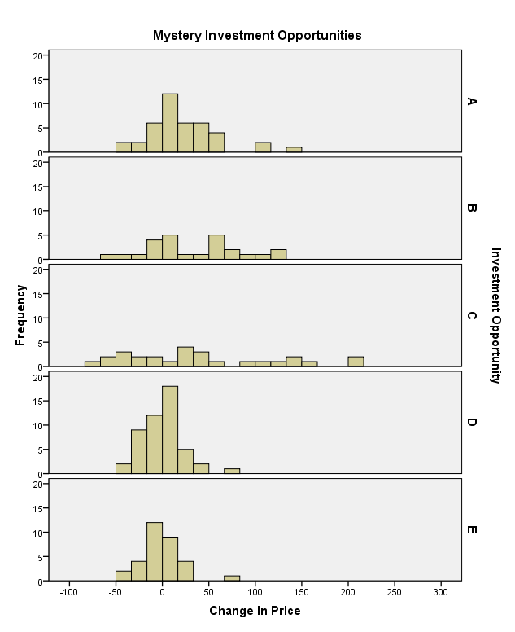
These histograms are made by following the same instructions as are given in question 6. Simply copy and paste each of you histograms onto your Preparation Assignment.
- Compare the histograms and descriptive statistics between the five companies. Describe the differences and similarities between the different graphs.
Answers will vary but should talk about shape, center, and spread of the different graphs and data sets. For example company C has the greatest spread of data, and the highest mean, while company E has the lowest mean.
- If you were saving for retirement, which of these five companies would be the most attractive investment? Justify your answer.
Answers may vary, students should choose a company and justify why. They will probably choose B or C, because they have the highest means.

- Create a table to compute the standard deviation “by hand” using the data Severe Bird Flu Data, available on the wiki page, http://byui-fdmat-wiki.pagodabox.com/index.php?title=Describing_Quantitative_Data:_Shape,_Center_%26_Spread )

Column 1 | Column 2 | Column 3
Observation, x | Deviation from the Mean | Squared Deviation from the Mean
39.1 | -0.229 | 0.052
39.5 | 0.171 | 0.029
38.9 | -0.429 | 0.184
39.2 | -0.129 | 0.017
39.9 | 0.571 | 0.326
39.7 | 0.371 | 0.138
39.0 | -0.329 | 0.108
Mean = 39.329 | Sum = 0 | Sum = 0.854
Variance: |  | 0.142
Standard Deviation: |  | 0.377

The steps to completing this calculation are as follows:
Step 01: Create the table and enter in each observation.
Step 02: Calculate the mean by adding all the observations together and dividing by the number of observations.
Step 03: Find the deviations from the Mean, by subtracting the mean from each observation. If you add up this column together it should always equal zero.
Step 04: Find the squared deviations from the mean, by simply squaring all the numbers you calculated for column two.
Step 05: Add up all the squared deviations. This should equal 0.854.
Step 06: Divide this sum by n-1, which in this case is 7-1 = 6. This is your variance and should = 0.142.
Step 07: Since the standard deviation is the square root of the variance, the last step is to take the square root of your variance. $\sqrt{0.142}=0.377$ = Standard deviation!

